Technical Assignment Writeup

Ledis web-based CLI application

# Introduction

Ledis (simple version of Redis) is a web-based CLI application that allows users to enter commands and display results. There are two main functions of Ledis: data structures function (String, Set) and special functions (Expire, Snapshot). In this writeup, I will describe the Ledis application design and share my thought process. Then, I will describe the challenges as well as interesting points of the project.

# Design Description

* 1. Data structures
     1. String
        1. **SET** key value

Set key to hold the string value. If key already holds a value, it is overwritten.

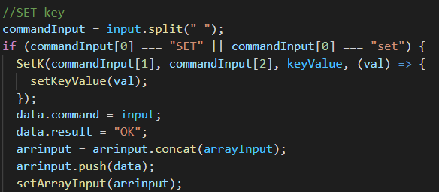

* + - 1. **GET** key

Get the value of key. If the key does not exist, nothing is displayed.

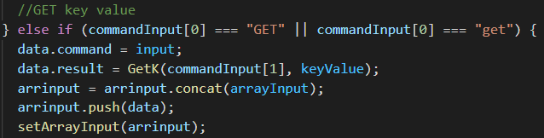

* + 1. Set
       1. **SADD** key value [value…]

Add values to the set stored at key.

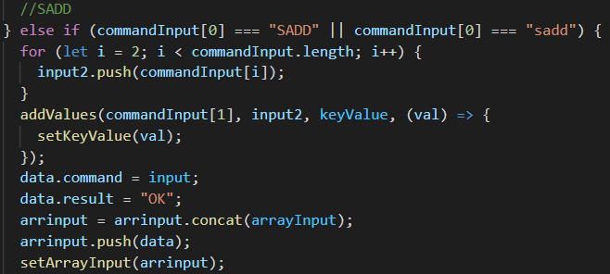

* + - 1. **SREM** key value [value…]

Remove values from set.

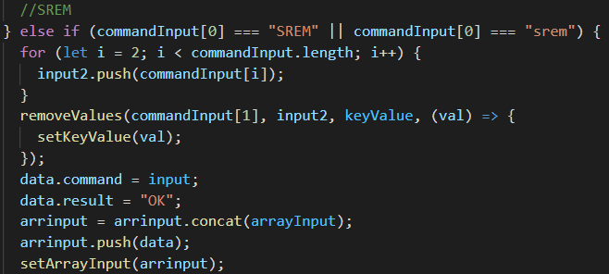

* + - 1. **SMEMBERS**

Return an array of all members of a set.

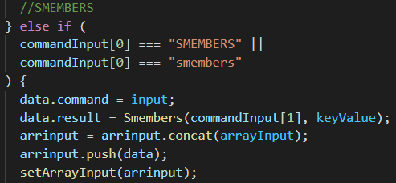

* + - 1. **SINTER** key [key ...] (not build yet)
  1. Special features
     1. Expire
        1. **KEYS**

List all available keys

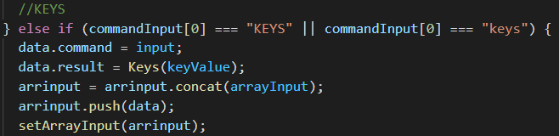

* + - 1. **DEL** key

delete a key.

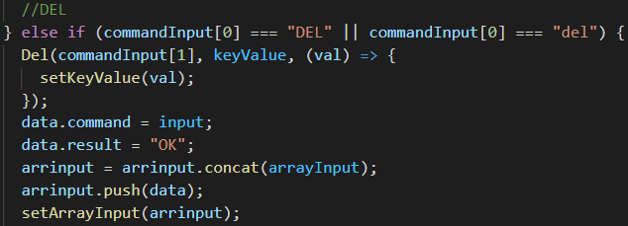

* + - 1. **EXPIRE** key seconds

set a timeout on a key

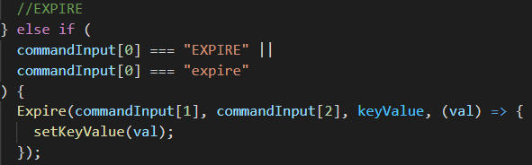

* + - 1. **TTL** key(not build yet)
    1. **Snapshot** (not build yet)

# Thought Process

Firstly, I built a simple CLI interface including a command line input and button to submit. Then I build a display command and result field. Before building the first function, I used split() to divide three elements of the command input (function name, key, value). About the Set function, I get the second input value used as an array key and the third input value is the value of the second one. About the Get function, I get the value of the key stored in the Set function. About the SADD function, I use a for loop to store multiple values into a key. About the SREM function, I use a for loop and find value in the key and remove it from the key. About the SMEMBERS function, I return the value from key to string format to display all values in key. About the KEYS function, I use return object and toString() to display all available keys. About the DEL function, I use delete object key to delete an available key. About the Expire function, I use setTimeout() to set expiration to a key.

# Challenges

Except for functions that I have not finished yet, the challenges I faced when building other functions were mostly about the logic design. It took me a lot of time to search for methods to build the function. Moreover, although I understand the logic, I can not add some functions that require conditions such as not allowing duplicates and showing values that do not exist. About the UI, I struggled to find the way to keep the input form at the bottom of the page and I still can not solve this.

# Interesting points

The interesting points of this project are:

* It requires a lot of logic to build the function and from the project I can practice my technical skills again after a semester and Tet holiday break.
* From the project, I understand that I still have to spend more time studying and practicing programming skills to successfully build all the functions required of the project.